Regional Map - SWC Temporary Staffing Services - Administrative, Professional, Industrial & Healthcare

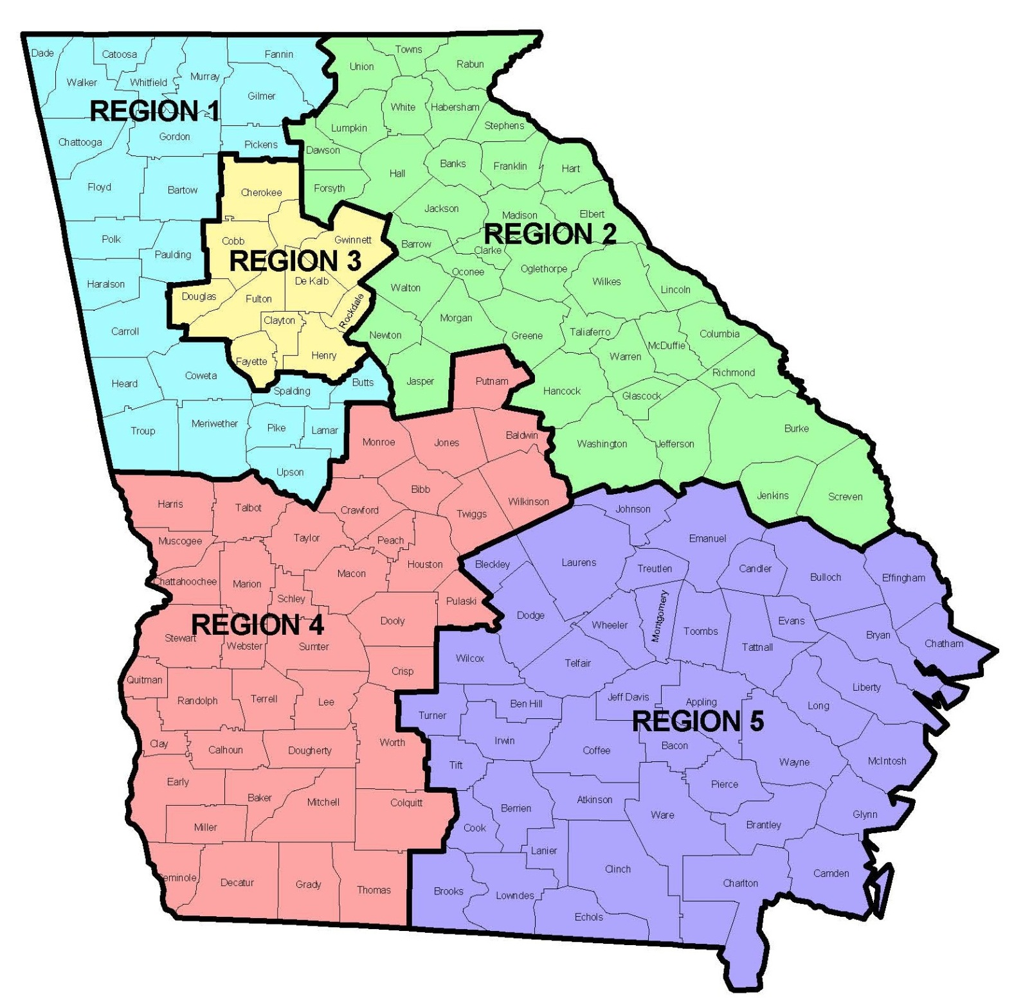

Region 1: 10 Counties / 8,261 Square Miles - Bartow (459.5), Butts (184.4), Carroll (499.1), Catoosa (162.2), Chattooga (313.3), Coweta (440.9), Dade(174.0), Fannin (389.7), Floyd (509.9), Gilmer (426.5), Gordon (355.8), Haralson (282.2), Heard (296.0), Lamar (183.5), Meriweather (501.2), Murray (344.5), Paulding (312.2), Pickens (232.1), Pike (216.1), Polk (310.3), Spalding (196.5), Troup (414.0), Upson (323.4), Walker (446.4), Whitfield (290.5)
Region 2: 39 Counties / 12,639 Square Miles - Banks (232.1), Barrow (160.3), Burke (827.0), Clarke (119.2), Columbia (290.1), Dawson (210.8), Elbert (351.1), Forsyth (224.0), Franklin (261.5), Glascock (143.7), Greene (387.4), Habersham (276.7), Hall (392.8), Hancock (471.8), Hart (232.4), Jackson (339.7), Jasper (368.2), Jefferson (526.5), Jenkins (347.3), Lincoln (210.4), Lumpkin (282.9), Madison (282.3), McDuffie (257.5), Morgan (347.4), Newton (272.2), Oconee (184.3), Oglethorpe (439.0), Rabun (370.0), Richmond (324.3), Screven (645.1), Stephens (179.1), Taliaferro (194.6), Towns (166.6), Union (321.9), Walton (325.7), Warren (284.3)
Region 3: 10 Counties / 2,974 Square Miles - Cherokee (421.7), Clayton (141.6), Cobb (339.6), Dekalb (267.6), Douglas (200.1), Fayette (194.3), Fulton (526.6), Gwinnett (430.4), Henry (322.1), Rockdale (129.8)
Region 4: 41 Counties / 14,664 Square Miles - Baker (341.9), Baldwin (257.8), Bibb (249.8), Calhoun (280.4), Chattahoochee (248.7), Clay (195.4), Colquitt (544.2), Crawford (324.9), Crisp (272.6), Decatur (597.1), Dooly (391.9), Dougherty (328.7), Early (512.6), Grady (454.5), Harris (463.9), Houston (375.5), Jones (393.9), Lee (355.8), Macon (400.6), Marion (366.0), Miller (282.4), Mitchell (512.1), Monroe (395.7), Muscogee (216.4), Peach (150.3), Pulaski (249.0), Putnam (344.6), Quitman (151.2), Randolph (428.2), Schley (166.9), Seminole (235.2), Stewart (458.7), Sumter (482.7), Talbot (391.4), Taylor (376.7), Terrell (335.4), Thomas (544.6), Twiggs (358.4), Webster (209.1), Wilkinson (447.3), Worth (570.7)
Region 5: 44 Counties / 18,976 Square Miles – Appling (507.1), Atkinson (339.4), Bacon (258.6), Ben Hill (250.1), Berrien (451.9), Bleckley (215.9), Brantley (442.4), Brooks (493.1), Bryan (436.0), Bulloch (672.8), Camden (613.0), Candler (243.0), Charlton (773.6), Chatham (426.4), Clinch (800.2), Coffee (575.1), Cook (227.2), Dodge (495.9), Echols (414.9), Effingham (447.7), Emanuel (680.6), Evans (182.9), Glynn (419.8), Irwin (354.3), Jeff Davis (330.7), Johnson (303.0), Lanier (185.3), Laurens (807.3), Liberty (489.8), Long (400.3), Lowndes (496.1), McIntosh (424.3), Montgomery (239.5), Pierce (316.5), Tattnall (479.4), Telfair (437.3), Tift (258.9), Toombs (364.0), Truetlen (199.4), Turner (285.4), Ware (892.5), Wayne (641.8), Wheeler (295.5), Wilcox (377.7)

